

**Lab No: 1 Date:**

**Title:** Write down the command to create the tree structure as given.

**Introduction of command prompt**

A command prompt is the input field in a text-based [user interface](https://www.techtarget.com/searchapparchitecture/definition/user-interface-UI) screen for an operating system (OS) or program. The prompt is designed to elicit an action. The command prompt consists of a brief text string followed by a blinking [cursor](https://www.techtarget.com/whatis/definition/cursor), which is where the user types of command prompt commands.

The command prompt is an [executable](https://www.techtarget.com/searchsecurity/definition/executable) CLI program, cmd.exe. At the command prompt, the user types a statement including a base [batch file](https://www.techtarget.com/searchwindowsserver/definition/batch-file) or a command name and any arguments to specify running conditions, logging and so on for the program. In Windows systems, such as Windows 10 and many previous versions of Windows, the command interpreter and executioner are referred to as the [Windows Command Processor](https://answers.microsoft.com/en-us/windows/forum/all/what-is-windows-command-processor/8a2c7d1c-158c-4502-9f8b-fe906ebff30c).

**Types of command prompt:**

**Internal command:** An internal command is an MS-DOS command that is stored in the system memory and loaded from command.com or cmd.exe. The illustration shows how commands contained within command.com are part of the command.com file. However, with the external commands, each command is a separate file.

**External command:** External commands are stored in the system memory after system booting. These external commands may easily be viewed, changed, deleted, or copied as they are present in the form of a file. External commands include FORMAT, SYS, EDIT, PROMPT, COPY, PRINT, TREE, SORT, etc.

C

D

E

File1.txt

File

2

.txt

Temporary

Source

Destination

File1.txt

File

2

.txt

**Root**

1.Write a command to create tree structure as given.

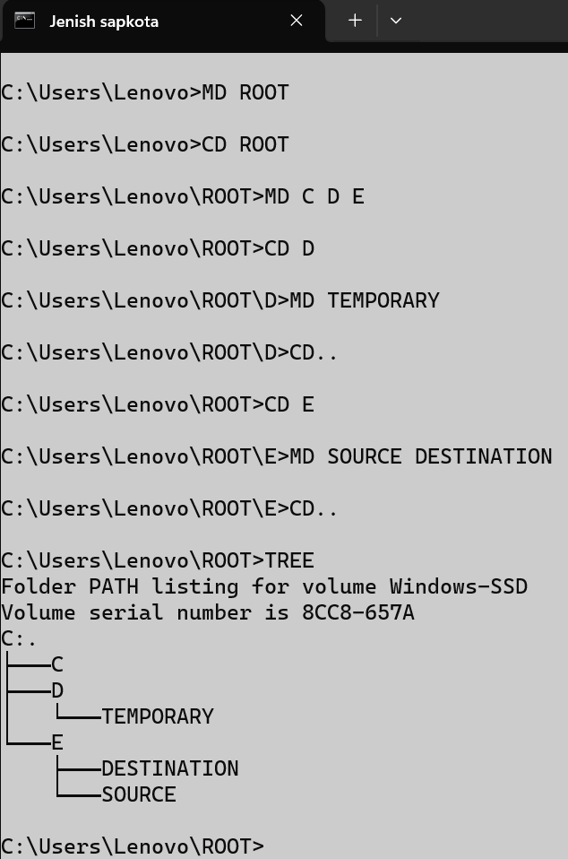

2.Create two files file1.txt and file2.txt in directory C.

3.Create two files file1.txt and file2.txt in directory destination

4. Rename the directory source into temporary and temporary into source.

